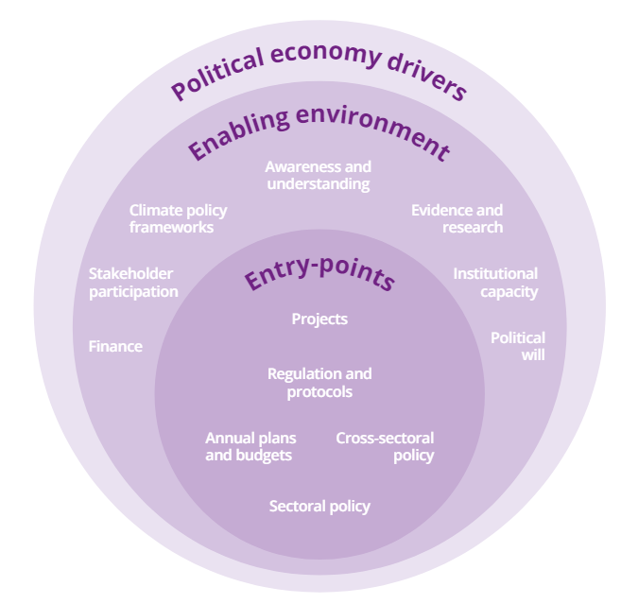
Fig 1. Framework developed by Oxford Policy Management for mainstreaming climate across sectors
Finance
Stakeholder participation
Climate policy frameworks
Awareness and understanding
Evidence and research
Institutional capacity
- Project
- Scheme
- Regulation
- Budget
- Policy
Entry points
Enabling
environment

